This n That

An e-mail newsletter from Agapé Athletics Club

Editor: Marieta Bortoli 082 466 7031 28 January 2019 www.agape.org.za

E-mail: marietabortoli@gmail.com

NB

- Next league race – 9 February
- Agapé race (Jacaranda City Challenge) – 12 October. Members to assist. PLEASE DIARIZE !!!!!!

Editorial

Take note that Hennie will be at Zita Park and Centurion time trials to assist members who wish to register.

We will be holding a “get to know one another” braai during February. Full details will be communicated to you next week.

Please refer to “In the mailbox” if you can assist with a Comrades and/or Two Oceans 56km entry (substitution).

Notice Board Additions

◊ Medihelp Sunrise Monster
◊

Attachments

□ Agapé registration form
□ ASA registration form

Birthday Greetings

May your birthday bring joy, contentment and may the Lord’s blessing surround you.

Mag jy in hierdie nuwe lewensjaar ‘n innerlike vrede ken wat jou in staat sal stel om die eise en behoeftes van elke dag in die seker wete van die Heer se teenwoordigheid tegemoet te gaan.

Gina Hughes 28 January | Robbie Stutterheim 29 January
Martie Boesenberg 31 January | Natalie Marais-Werner 01 February
Fanie Boousen 02 February | Walter Meyer 05 February
Louw van Zyl 06 February | Koos Hofmeyr 07 February
Mia Reynecke 07 February | André van Staden 08 February
Marcel Hattingh 18 February | Cornel Maartens 18 February
Stefan Bothma 19 February | Rieme Engelbrecht 22 February
Laetitia van Wyk 22 February | Kay Liebenberg 23 February
Carel Wolhuter 27 February | Jaco Barkhuizen 28 February

Personalia

Welcome new and former members

Fanie Booysens Marike Boudouris Leon Klopper
Lesego Motlogedi Lizzy Oberholzer Elvis Rasebotse
Carolien Schutte Gert Smith Corne Vermaak

In the mailbox

Comrades entry
Hallo mede-atlete, ek is op soek na n 56km ultra inskrywing (substitution entry) vir die 2019 Twee Oseane maraton op 20 April en/of die 2019 Comrades wedloop. Kan iemand help? Louis 0822946284 of louisfourie2008@hotmail.com – Dankie

Hi there fellow athletes, I am searching for a 56km ultra entry (substitution entry) for the 2019 Two Oceans marathon on 20 April and/or the 2019 Comrades marathon. Can anyone help me? Louis 0822946284 or louisfourie2008@hotmail.com - Thanx

General
Registration fees 2019:
First member R400,00
Second member/pensioner/student R350,00
Junior (under 19 – copy of ID document required) R100,00
Social member R100,00

The fees include the ASA licence number.

Kindly visit our website: www.agape.org.za for further information.

==

Clothing available:
Buffs @ R100
Ladies skirts @ R200
Second skins @ R220
Age tags @ R30

The items will also be available at races, please visit our gazebo

Congratulations

Congratulations to the following members:

Thank you’s

Thank you to Elbert Loubser for the weekly race report and Elise Loubser our newest photographer. Much appreciated.
Race reports/Upcoming race information

Race report feedback Wonderpark Akasia 3-in-1, 26 January 2019, 21.1 km (Elbert Loubser):
Although a little unusual, the early 05:30 starting time for the marathon (42.2) and half-marathon (21.1) distances were ideal, considering our Transvaal/Gauteng highveld temperatures which can quite easily soar into the high 30-degree Celsius margins. Pete (MC), already in attendance, welcomed us with music and during the morning relayed the necessary information on topics, such as 'where the start is'. It is uncanny as to how different things appear during the dark, as opposed to when daylight has crept in. Granted, the blow-up finish arch was somewhat hidden between the trees and the starting blocks for the various distances are outside the Wonderpark shopping Centre terrain in Dieffenbachia Street, both sort of hidden from plain sight, should one not be familiar with the layout.

The Akasia marathon itself, is quite popular for those seeking an 'early in the year' Comrades qualifier. Many moons ago, the undulating hills of Berg Ave (Berglaan) was still part of the route. Not anymore. With gradual ups and downs, plenty of shade, the route is thus ideally suited to be utilised as a Comrades qualifier, should one have such aspirations.

As the race progressed, the cloud cover imperceptibly increased, keeping sun rays at bay. A slight breeze contributing to quite acceptable running conditions for the first three hours.

At the traffic circle, a right into 1st Avenue takes us over the R80 (Mabopane Highway), left into Boundary Road, a right into John Street. The field of athletes slowly spreading out as one settles into a preferred/planned stride. Somewhere along John Street, Chris Burger speeds by, with a greeting and a passing quip uttered in the lines of being mentioned in the race report. :-) A right brings us back to 1 st Ave, which becomes Oribi Street. We go past Akasia High School (ex-home of the Dawn-2-Dusk 12-hour circuit relay race, also presented by Akasia - Gerrie Strydom). Many lefts and rights brought us into Verecunda Street, adjacent to Gerrit Maritz High School (the current venue of the Dawn-2-Dusk 12-hour circuit relay race).

Punctata Street (which has an ever so slight climb section), Barbara Street (lovely downhill section here), Bokmakierie Street (flat), Waterbok Street (flattish), Grysbok Ave, Eekhoring Street (slight down), Hartbees Ave (slight up), 2nd Ave (flat with a watering point), 3rd Ave (flat) and Iris Street (down and up) were 'conquered' and left behind. Iris Street brought us back into 1st Ave, back over the R80 bridge, now started to smell 'home'. Somewhere in Theresa Park, a bakkie with a trailer (the latter loaded with boxes/water sachets etc) drove past slowly, a glance in the right rear view mirror, our eyes met momentarily, a wave of the hand, a nod of the head: Yip, that was Gerrie Strydom. :-)

On Saturday, I was once again reminded as to how important something like the Agapé gazebo(s) base station has become. Just having a chair to sloth down onto and be able to 'regroup' one self, a shade to lie under and put one's legs up on a chair (leg muscles absolutely adore this), to sample an ice-cold slice of watermelon and then enjoy a welcome cup of coffee. Yip, just to 'belong', now that is something to treasure. Thank you, Hennie, and Marix.

Thank you, Akasia Athletics Club, for a well organised race.
Congratulations to those athletes who were able to qualify for Comrades. I need to add, for those who might have been disappointed, it is still rather early in the year, be patient with the body. Allow the body to adjust. A marathon, is a marathon, is a marathon. Respect!
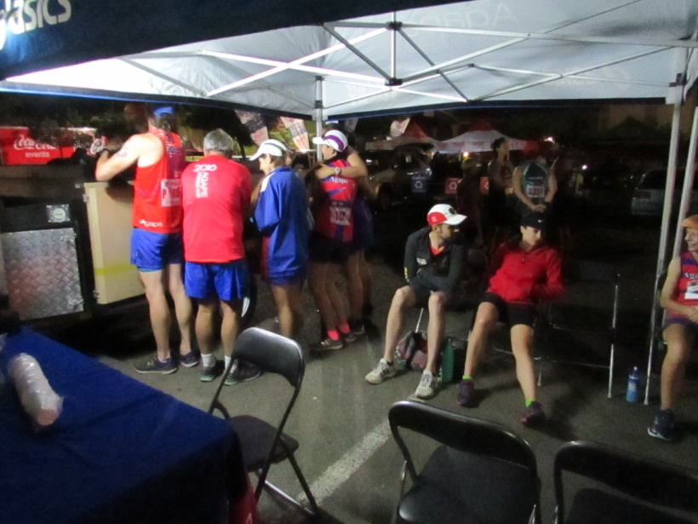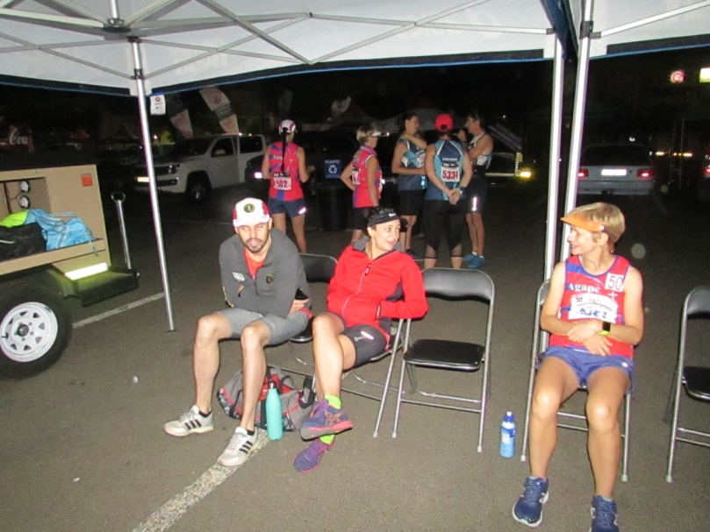
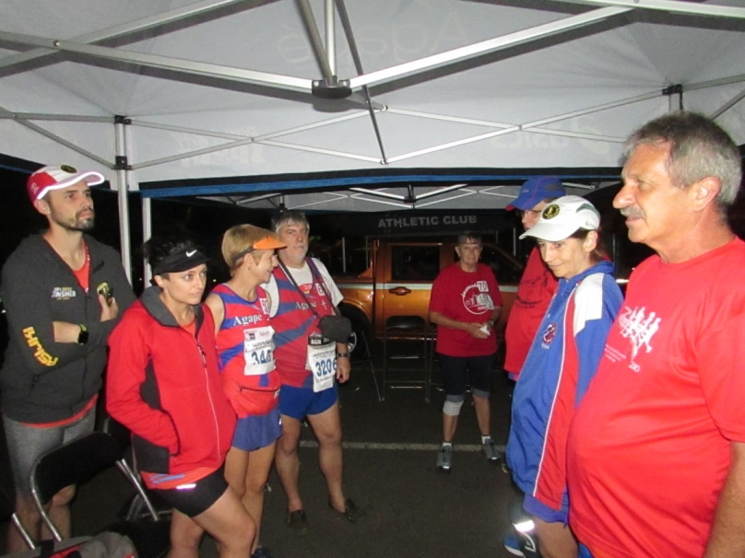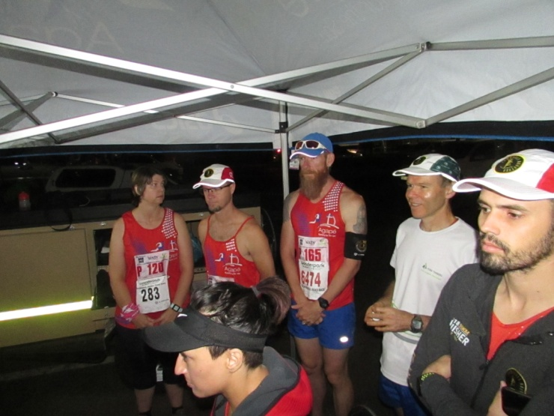

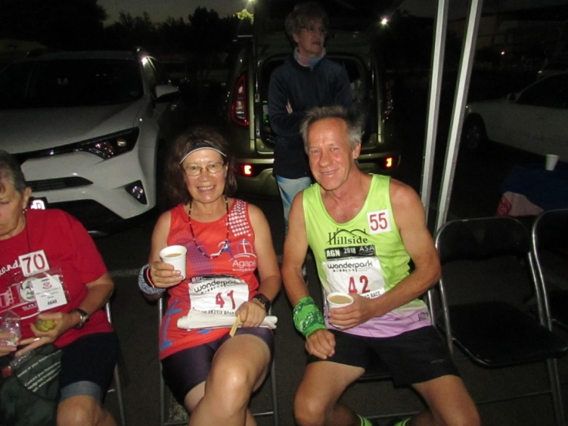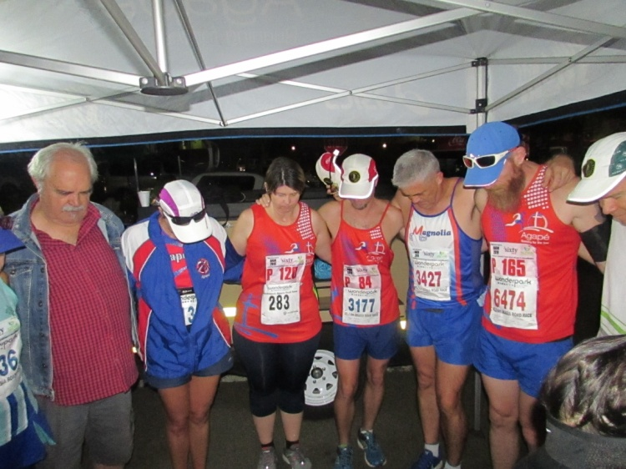

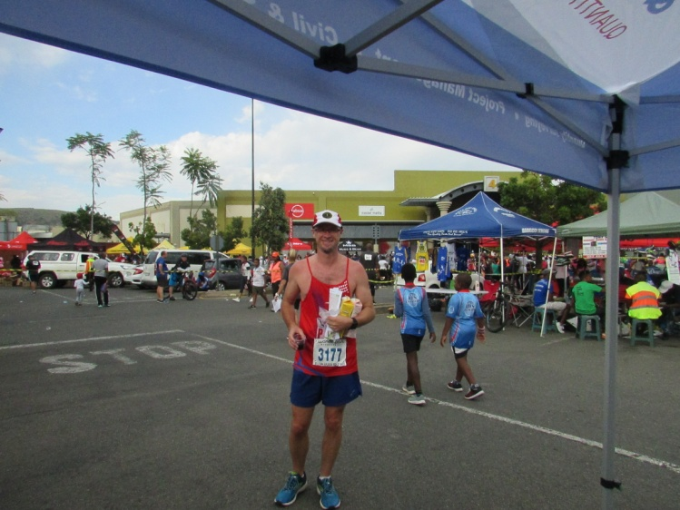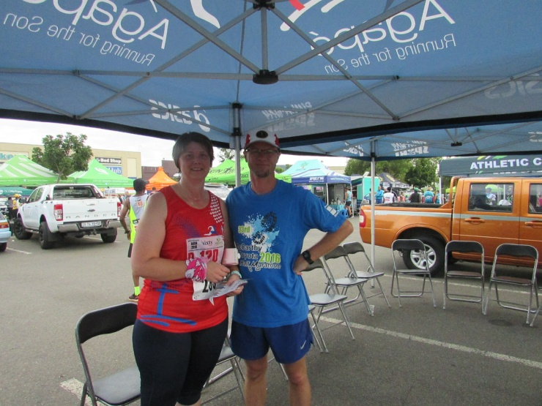
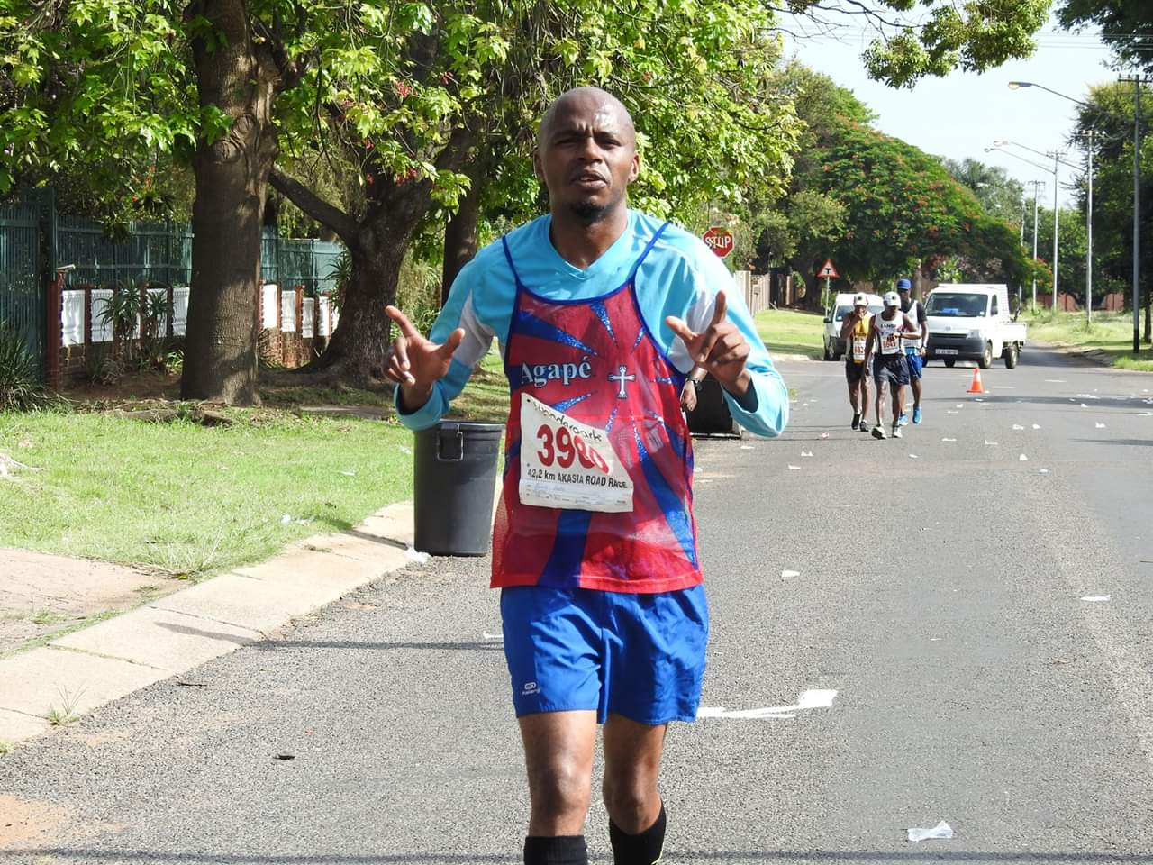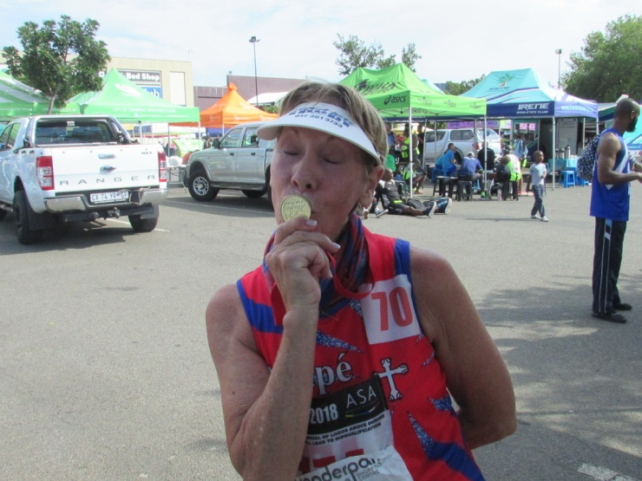
Yip, that is a gold medal Gina is kissing! :-)

Race Results
Ace (AGN) 10km race - 2019-01-12
Position | Initials | Surname | Sex | Age | Finish Time
112 | E | Du Plessis | M | 35 | 00:55:51
255 | E | Fourie | F | 51 | 01:05:29
345 | N | Adams | F | 44 | 01:09:33
423 | C | Hughes | F | 70 | 01:12:24
429 | H | Venter | F |  | 01:12:56
538 | L | Erasmus | M | 79 | 01:17:18
628 | T | Oelofse | F | 44 | 01:21:15
745 | R | Sher | M | 75 | 01:27:25
973 | M | Greeff | F | 54 | 01:43:02
1018 | E | Loubser | M | 61 | 01:49:25
Ace (AGN) 21km race - 2019-01-12
Position | Initials | Surname | Sex | Age | Finish Time
70 | J | Van Der Merwe | M | 49 | 01:47:25
264 | H | Baker | M | 45 | 02:04:43
265 | C | De Kiewit | M | 59 | 02:05:51
296 | M | Atkins | F | 49 | 02:08:12
317 | L | Van Wyk | F | 42 | 02:10:01
399 | C | Burger | M | 54 | 02:15:34
434 | W | Focaraccio | F | 36 | 02:18:04
664 | E | Van Zyl | F | 41 | 02:35:11
771 | M | Venter | F | 59 | 02:49:35
794 | A | Te Reh | M | 69 | 02:55:09
814 | C | Mouton | F | 62 | 03:04:14
Akasia Wonderpark (AGN) 21km race - 2019-01-26
Position | Initials | Surname | Sex | Age | Finish Time
135 | S | Marais-werner | F | 44 | 01:49:03
164 | W | Reinecke | M | 44 | 01:52:01
172 | F | Booysen | M | 59 | 01:52:47
491 | C | Burger | M | 54 | 02:11:36
565 | E | Fourie | F | 51 | 02:14:47
681 | A | Marais-werner | F | 44 | 02:19:24
795 | T | Oelofse | F | 44 | 02:23:46
809 | L | Fourie | M | 47 | 02:24:14
836 | M | Boesenberg | F | 61 | 02:25:04
855 | A | Moolman | F | 30 | 02:26:17
856 | H | Moolman | M | 30 | 02:26:35
1069 | G | Hughes | F | 70 | 02:33:56
1179 | L | Groenewald | F | 47 | 02:40:18
1203 | C | Mouton | F | 62 | 02:41:10
1217 | A | Manganye | M | 52 | 02:41:58
1287 | M | Venter | F | 59 | 02:45:28
1288 | H | Venter | M | 59 | 02:45:29
1464 | E | Loubser | M | 62 | 02:55:21
Akasia Wonderpark (AGN) 42km race - 2019-01-26
Position | Initials | Surname | Sex | Age | Finish Time
243 | K | Imrie | M | 47 | 03:45:35
482 | J | Van Der Merwe | M | 49 | 04:04:51
521 | B | Kgasi | M | 38 | 04:09:14
877 | F | Schunke | M | 51 | 04:34:21
1558 | D | Benadie | F | 52 | 05:29:19

League results

Training/Health snippets

Ten Tips to Prevent Running Injuries

1. Improve and maintain your flexibility
- Daily stretching is essential to improve and maintain flexibility, which in turn will help improve performance and prevent injuries.
- Stretching should be done after you warm up your muscles – usually about 10 minutes of warm up should be enough.
- Stretching should never be done in a hurry and should include all joints and extremities. Each stretch should be held in place for 30 seconds without bouncing.
- It is helpful to include sports specific dynamic exercises like high knee drills, skipping, bounding, arm circles, and cross body arm swings.

2. Include strength training in your running program
- Strength training improves a runner’s body strength and overall athleticism. This in turn reduces muscular fatigue that leads to poor performance and injuries. Runners will benefit from a program of 2-3 strength training sessions per week.
- Strength training exercises should focus on all muscle groups including the trunk and upper and lower body.
- Weight lifting, plyometrics and hill running are all effective methods of increasing strength.
- Focus on improving strength in the offseason and pre-season and maintaining while in season.

3. Stay hydrated and eat a well-balanced diet
- Avoid heat exhaustion and dehydration by pre-hydrating two hours prior to practice or competition with 16-20 ounces of fluids and another 8-10 ounces after warm-up.
- Take in 6-8 ounces of fluids every 15-20 minutes of exercise.
- Within two hours after exercise, re-hydrate with a pint (20-24 ounces) of fluid for every pound of weight lost during exercise.
- The best fluids to take before, during, and after exercise are a cooled 4-8% carbohydrate solution.

4. Warm up and cool down before and after all runs and races
- Before practices and competitions, it is important to warm up. The faster the workout or race, the longer the warm up needed. A warm up of 5-10 minutes helps to flush out lactic acid build-up in muscles and prevents delayed muscle soreness.

5. Gradually increase your mileage and periodize your training schedule
- Good aerobic activity is the foundation of your running performance. The principle of progression and periodization means gradually preparing the body to handle workout stress. You slowly build up the amount of training you do along with bumping up the intensity.
- Periodization is the structure in a training program to progressively increase the training stress from cycle to cycle.
- The progression should not be a steady increase in volume and intensity, but instead should be a staircase progression with periods of reduced volume and intensity at certain times during a training period, season, or year.
- Increases in training volume, duration and intensity should be a gradual increase of 5-10% per week.

6. Cross-train and include rest days in your training schedule
- Cross-training helps to maintain your aerobic fitness while avoiding excessive impact forces from too much running.
- Including rest days in your training schedule allows your body to recover and adapt to a running workout.

7. Talk with a running expert or coach to analyse your training program
- Overtraining, running injuries and poor performances are often the result of an ineffective training program.
- A good running coach can help you develop an appropriate training schedule to meet your running goals and prevent injury.

8. Wear the correct type of running shoes based on your foot type and running style
- Not all running shoes are made alike. The type of shoe you need varies depending upon your foot type and style of running. A sports store that specializes in athletic footwear can you help you figure out what style might be best for you.
- Foot type is based upon the structure of your foot and the degree of pronation. Pronation is the normal inward rolling of your foot in running as your foot strikes the ground and transitions into pushing off. Abnormal pronation can lead to injuries.

9. Have a formal gait analysis performed and use orthotics if recommended
- Poor foot biomechanics such as heel strike, excessive pronation, or a very rigid or very flexible foot arch can lead to inefficiency and injuries.
- Most runners can control these problems by carefully selecting the right shoe type or by seeing an expert that can analyse your running gait and make orthotic inserts specific to your foot structure.

10. Have your running form evaluated by a running expert
- Better running economy and body awareness are achieved through developing an efficient and smooth-running form. A smooth-running form requires less energy and delays muscle fatigue.
- A person trained in running biomechanics can help detect flaws in your running form and show you how to correct them.

Your thought for the week
Life is essentially an endless series of problems. The solution to one problem is merely the creation of the next one. Don’t hope for a life without problems. There’s no such thing. Instead, hope for a life full of good problems.

Your smile for the week
A: I have the perfect son.
B: Does he smoke?
A: No, he doesn’t.
B: Does he drink whiskey?
A: No, he doesn’t.
B: Does he ever come home late?
A: No, he doesn’t.
B: I guess you really do have the perfect son. How old is he?
A: He will be six months old next Wednesday.
==
I tell people I'm on a low-carb diet. But in reality, I just eat pasta while lying on the floor.

Something to ponder over / something spiritual
Pancakes

Six-year-old Dan decided one Saturday morning to fix his parents pancakes. He found a big bowl and spoon, pulled a chair to the counter, opened the cupboard and pulled out the heavy flour canister, spilling it on the floor.

He scooped some of the flour into the bowl with his hands, mixed in most of a cup of milk and added some sugar, leaving a floury trail on the floor which by now had a few tracks left by his kitten.

Dan was covered with flour and getting frustrated. He wanted this to be something very good for Mom and Dad, but it was getting very bad.

He didn't know what to do next, whether to put it all into the oven or on the stove, and he didn't know how the stove worked! Suddenly, he saw his kitten licking from the bowl of mix and reached to push her away, knocking the egg carton to the floor. Frantically, he tried to clean up this monumental mess but slipped on the eggs, getting his pyjamas white and sticky.

Just then he saw Dad standing at the door. Big crocodile tears welled up in Dan's eyes. All he'd wanted to do was something good, but he'd made a terrible mess. He was sure a scolding was coming, maybe even a spanking. But his father just watched him.

Then, walking through the mess, he picked up his crying son, hugged him and loved him, getting his own pajamas white and sticky in the process. That's how God deals with us. We try to do something good in life, but it turns into a mess. Our marriage gets all sticky, we insult a friend, we can't stand our job, or our health goes sour.

Sometimes, we just stand there in tears because we can't think of anything else to do. That's when God picks us up and loves us and forgives us, even though some of our mess gets all over Him.

But just because we might mess up, we can't stop trying for God or for others. Sooner or later, we'll get it right, and then they'll be glad we tried.

Cancelled Races

Notice Board

Useful Links:
www.raceresults.co.za/flyers - for the latest race pamphlets
www.agn.co.za/#League for the latest league logs and the league points you earned
http://www.agn.co.za/Docs/2018/Walking/AGN%20road%20walking%20stds%20ref%20685.pdf
AGN 2017 RW qualifying standards and selection criteria
www.runawaysport.co.za Run-A-Way Sport’s web site
www.verticalhorison.co.za Trail Running www.trailseries.co.za Trail Running
http://www.mastersathletics.net/Age-Graded-Calculator.2595.0.html Age Graded Calculator

Saturday 2 February Intercare Classic Road Race 21.1/10/5 km
Race Organisers: Magnolia Road Runners
Venue: Rietondale Park, North Road, Rietondale
GPS: S 25 43.980 E 28 13.239

 | 21.1 km | 10 km | 5 km
Pre-entry fee | R 130 | R 90 | R 50
Pre-entry fee 60 - 79 | R 60 | R 50 | R 50
Entry fee 1 & 2 February | Closed | R 110 | R 50
Entry fee 1 & 2 February 60 - 79 | Closed | R 50 | R 50
Entry fee 70+ & blind runners | Free
Start Time | 06:00 | 06:20 | 06:25
Cut-off | 03:00 | 02:00 | 01:00

Event t-shirt @ R80 each

1st 1000 on-line entries will receive a goody bag

No Pets

Pre-entries at: Run-away Sport; Sweatshop Southdowns, Dunkeld West, Bedfordview; Sportmans Warehouse Woodmead, Randburg, Centurion, Kolonnade Centre, Atterbury Value Mart

www.intercare.co.za

League Race
Saturday 9 February Bronkhorstspruit Race 32/10/4 km
Race Organisers: Bronkhorstspruit Athletics Club
Venue: Hoërskool Erasmus, Kerk Street, Bronkhorstspruit (take Delmas off ramp)

 | 32 km | 10 km | 4 km
Entry fee | R 150 | R 80 | R 20
Entry fee 60+ | Free
Start Time | 06:00 | 06:15 | 06:30
Cut-off | ??

1st 200 32km entries at Run-Away Sport receive a t-shirt

No Pets

Pre-entries at: Run-away Sport

www.enteronline.co.za

Saturday 16 February Bestmed Tuks Race 42.2/21.1/10/5/1 km
Race Organisers: Tuks Sport
Venue: Hillcrest Sports Campus, Burnett Street, Hatfield
GPS: S 25 44’58” E 28 14’47”

 | 42.1 km | 21.1 km | 10 km | 5km | 1 km
Entry fee | R 200 | R 150 | R 100 | R 50 | R 30
Entry fee 60 - 79 | R 100 | R 75 | R 50
Entry fee 80+ / blind athletes | Free
Start Time | 05:30 | 06:00 | 06:30  Wheelchair  06:20 | 06:40 | 08:00
Cut-off time | 05:30 | 03:00

42.2km race is a pre-entry race only and limited to 4000

No Pets

Only the 10km race is wheelchair friendly

Pre-entries at: Run-away Sport; Sweatshop Southdowns, Dunkeld West, Fourways Crossing; Tshwane Running Shop; UP Hatfield Campus

www.entrytime.com

Sunday 24 February The Deloitte Challenge 42.2/21.1/10 km (Pretoria Marathon)
Race Organisers: Phobians Athletics Club
Venue: Pretoria High School Old Boys Club, Hofmeyr Park, Queens Crescent, Lynnwood

 | 42.2 km | 21.1 km | 10 km
Entry fee | R 200 | R 140 | R 90
Entry fee 70+ (attach copy of ID to entry form) | Free
Start Time | 06:00 |  | 06:15
Cut-off | 05:30

42.2/21.1km entries open until 23 February – no race day entries

1st 4 500 pre-entries receive a free t-shirt

No Pets

Wheelchair athletes only recommended on 10km but are allowed on longer distances but will need assistance over animal grids

Pre-entries at: Run-away Sport; Sweatshop Southdowns, Dunkeld, Bedfordview

www.entrytime.com

Saturday 2 March Medihelp Sunrise Monster 32/21.1/10/5 km
Race Organisers: Harlequin Harriers
Venue: Harlequin Club, Totius Street, Groenkloof
GPS: S 25’46.122 E 28’13.031

 | 32km | 21.1km |  |  | 10 km | 5 km
Pre-entry fee | R 160 | R 150 |  |  | R 100 | R 50
Entry fees 60+ | R 80 | R 70 |  |  | R 50 | R 40
Start Time | 06:03 |  |  |  | 06:30 | 06:45
Time Limit | 04h30 |  | 03h30 | 02h300

Route not suitable for wheelchair athletes

Pre-entries: Run-A-Way Sports, Sweatshop Dunkeld, Bedfordview & Southdowns; Natural Runner

2019 AGN LEAGUE FIXTURE LIST
EVENT | DISTANCE | DATE | LEAGUE
 |  |  | RR | RW
Bronkhorstpruit | 32/10 km | 09/02/19 | X | X
Medihelp Sunrise Monster | 32/21.1/10 km | 02/03/19 | X | X
Run Against Drugs | 21.1/10 km | 13/04/19 | X | X
Skosana Development Run | 21.1/10 km | 25/05/19 | X | X
Race of Friendship | 21.1/10 km | 29/06/19 | X | X
Zwartkop Road Race | 21.1/10 km | 27/07/19 | X | X
Spirit of Flight | 10 km | 31/08/19 | X | X
Brooklyn Road Race | 21.1/10 km | 07/09/19 | X | X
Capital Classic | 21.1/10 km | 05/10/19 | X | X
Freedom of Expression | 21.1/10 km | 02/11/19 | X | X

Masters Athletics Fixture list

South Africa
? March 2019 KZN Kings Park Stadium
29/30 March 2019 PE Westbourne Oval
29/30 March or 19/20 April 2019 GNMA Pilditch
5/6 April 2019 WP Cape Town
13 April 2019 CGMA Herman Immelman
10 August 2019 Mpumalanga Secunda
? October 2019 Rassies Bronkhorstspruit
25/26 October 2019 SWD Oudtshoorn
8/9 November 2019 Free State Bloemfontein

South African Championships
3/4 May 2019 SWD Oudtshoorn
April/May 2020 Central Gauteng Herman Immelman

Africa Championships
2021 Nairobi, Kenya
2023 South Africa

International Championships
24-30 March 2019 WMA Indoor Torun, Poland
28/9-6/10 2019 30th Summer universiade Naples, Italy
20/7/2020 – 1/8/2020 World Masters athletics Champs Toronto, Canada
Time Trials:

Centurion - Wednesdays at 17:30
Lewende Woord Centurion
Contact Marinda 654 5800 (h) / 082 720 9017

Zita Park - Tuesdays at 17:30
Zita Street, Zita Park, Garsfontein
Contact Hennie Venter – 082 676 6792

Gazebo Enquiries

Hennie Venter – 082 676 6792

Intercessor:



Jaco Barkhuizen 083 519 1737

Agapé Executive 2018/2019

Name | Position | Telephone number | E-mail address
Hennie Venter | Chairperson | 082 676 6792 | henniev@seng.co.za  venterhennie08@gmail.com
Hennie Venter | Registrar | 082 676 6792 | henniev@seng.co.za  venterhennie08@gmail.com
Marieta Bortoli | Treasurer & Vice chairperson | 082 466 7031 | marietabortoli@gmail.com
Marieta Bortoli | Secretary | 082 466 7031 | marietabortoli@gmail.com
Hennie Venter | Club Captain | 082 676 6792 | henniev@seng.co.za  venterhennie08@gmail.com
De Wet de Beer | Race organizer | 082 373 2987 | dewet@styletechnique.co.za
De Wet de Beer | PRO | 082 373 2987 | dewet@styletechnique.co.za
Marieta Bortoli | Editor | 082 466 7031 | marietabortoli@gmail.com
Jaco Barkhuizen | Intercessor | 083 519 1737 | jaco00028@gmail.com
 | Clothing co-ordinator | Vacant
 | General activities | Vacant
Gustav Brink | Statistician | 083 417 8431 | gustav.brink@gmail.com

Agapé Executive


Hennie Venter Marieta Bortoli De Wet de Beer


Jaco Barkhuizen Gustav Brink (Ex-officio)

